SPECIAL NOTICE

The Office of Mineral Resources on behalf of the State Mineral and Energy Board is advertising in the “The Notice of Publication” for receipt of sealed bids on or before noon on Tuesday, November 7, 2023 for an Exclusive Geophysical Agreement Type 3 to be awarded upon Tract 45685 at its November 8, 2023 Lease Sale. By Virtue of this public notice, Tract No. 45685, Iberia, St. Mary, Terrebonne, and Vermilion Parishes, Louisiana is being advertised for the November 8, 2023 Sale as follows:

EXCLUSIVE GEOPHYSICAL AGREEMENT TRACT NO. 45685 – Iberia, St. Mary, Terrebonne, and Vermilion Parishes, Louisiana
The Exclusive Geophysical Agreement is a Type #3, and carries a maximum
Initial Term of Eighteen (18) months, with an Option Term, if exercised by additional payment as specified in the Agreement, of Six (6) months period. The Exclusive Geophysical Agreement #3, shall be effective from November 8, 2023 for a period terminating May 8, 2025, unless the Option period is activated by payment (timely) of the Option payment amount set forth in the Agreement, in which case the termination date shall be November 8, 2025,and which Agreement authorizes the successful bidder to conduct at least 3-D geophysical operations on all of the lands, including any islands and/or accretion or reliction to lakes, bays, the coastline or otherwise, where allowed by law, together with all lands now or formerly constituting the beds and bottoms of all water bodies of every nature and description, as to which title is vested in the State of Louisiana, and not presently under mineral lease as of November 8, 2023, situated in the Parish(es) of Iberia, St. Mary, Terrebonne, and Vermilion, Louisiana, and more particularly described as follows: Beginning at a point having Coordinates of X = 1,772,376.46 and Y = 425,260.47; thence South 89 degrees 43 minutes 37 seconds East 67,041.27 feet to a point having Coordinates of X = 1,839,416.97 and Y = 424,940.97; thence South 00 degrees 10 minutes 28 seconds East 38,989.14 feet to a point having Coordinates of X = 1,839,535.76 and Y = 385,952.01; thence North 82 degrees 43 minutes 23 seconds East 63,324.30 feet to a point having Coordinates of X = 1,902,350.00 and Y = 393,973.14; thence South 00 degrees 42 minutes 13 seconds West 49,569.48 feet to a point having Coordinates of X = 1,901,741.21 and Y = 344,407.40; thence North 78 degrees 21 minutes 45 seconds East 24,615.45 feet to a point having Coordinates of X = 1,925,850.66 and Y = 349,372.78; thence Southeasterly approximately 39,900 feet to the Northwest corner of the boundary of the Atchafalaya Delta Wildlife Management Area; thence along the boundary of said Atchafalaya Delta Wildlife Management Area the following courses: Northeasterly, Easterly, Southwesterly, Southeasterly, Easterly, Southerly, Southeasterly, Northerly, Easterly and Southeasterly to a point; thence Southeasterly approximately 42,158 feet to a point having Coordinates of X = 2,072,523.25 and Y = 244,755.75; thence South 02 degrees 27 minutes 51 seconds West 98,490.25 feet to a point having Coordinates of X = 2,068,288.70 and Y = 146,356.58; thence North 68 degrees 01 minutes 09 seconds West 334,545.14 feet to a point having Coordinates of X = 1,758,061.95 and Y = 271,575.62; thence North 00 degrees 33 minutes 04 seconds West 43,703.40 feet to a point having Coordinates of X = 1,757,641.60 and Y = 315,277.00; thence North 02 degrees 19 minutes 07 seconds West 17,677.62 feet to a point having Coordinates of X = 1,756,926.41 and Y = 332,940.15; thence North 86 degrees 53 minutes 17 seconds West 11,317.99 feet to a point having Coordinates of X = 1,745,625.11 and Y = 333,554.55; thence North 02 degrees 06 minutes 40 seconds East 26,002.26 feet to a point having Coordinates of X = 1,746,582.91 and Y = 359,539.16; thence North 89 degrees 44 minutes 12 seconds West 16,836.27 feet to a point having Coordinates of X = 1,729,746.82 and Y = 359,616.58; and North 33 degrees 00 degrees 00 minutes East 78,271.36 feet to the point of beginning, LESS AND EXCEPT all that portion, if any, of State Lease Nos. 329, as amended, 340, as amended, 500, as amended, 1706, as amended, 2276, as amended, 2366, 2585, 3184, as amended, 3306, as amended, 3317, as amended, 3498, as amended, 3586, 3909, 4011, as amended, 18640, 19139, as amended, 19266, 20035, 20181, as amended, 20219, 20220, 20221, 20222, 20223, 20224, 20367, as amended, 20368, 20369, 20518, 20526, 20527, 20528, as amended, 20529, as amended, 20530, as amended and 20753, as amended, 21608, 21614, as amended, 21615, 21616, 22107, as well as Operating Agreements AO302 and AO391 that may lie within the above described tract, LESS AND EXCEPT all that portion, if any, of the Marsh Island Wildlife Refuge that lies within the above described tract, and LESS AND EXCEPT all that portion of the Louisiana State Wildlife Management Area and Game Preserve (Ward AND McIlhenny donation) that lies within the above description, and LESS AND EXCEPT any right, title, and interest in lands owned by and not under lease from the State of Louisiana, situated in Sixteenth Sections or Indemnity Lands, contained within the above described tract, containing approximately 640,671.77 acres, LESS AND EXCEPT all that portion, if any, lying seaward of the line three nautical miles from the coastline of Louisiana, as said three-mile line has been decreed by the Supreme Court of the United States, as determined by a Special Master appointed therein, in litigation styled United States v. State of Louisiana et al No. 9 Original, in 1975, all as more particularly outlined on a plat on file in the Office of Mineral Resources, Department of Natural Resources. All bearings, distances and coordinates are based on the Louisiana Coordinate System of 1927, (North or South Zone), where applicable.

NOTE: The 3D program will have Maximum In-Line offset of up to 30,000 ft., Maximum Cross-Line offsets of 30,000 ft. with a Bin size of 110 ft. X 110 ft. Nominal fold will be up to 3600 fold with over 2,000,000 traces per square mile and the project will deploy over 140,000 channels. The 3D survey design will emphasize dense spatial sampling and full offset sampling to capture the highest fidelity imaging of all subsurface features regardless of orientation or dip. The survey will image both shallow and deep geological features with the highest resolution to date.

NOTE: The above description of the Tract nominated for this agreement has been provided and corrected, where required, exclusively by the nomination party. Any mineral lease selected from this Tract and awarded by the Louisiana State Mineral and Energy Board shall be without warranty of any kind, either express, implied, or statutory, including, but not limited to, the implied warranties of merchantability and fitness for a particular purpose. Should the mineral lease awarded by the Louisiana State Mineral and Energy Board be subsequently modified, cancelled or abrogated due to the existence of conflicting leases, operating agreements, private claims or other future obligations or conditions which may affect all or any portion of the leased Tract, it shall not relieve the Lessee of the obligation to pay any bonus due thereon to the Louisiana State Mineral and Energy Board, nor shall the Louisiana State Mineral and Energy Board be obligated to refund any consideration paid by the Lessor prior to such modification, cancellation, or abrogation, including, but not limited to, bonuses, rentals and royalties.

NOTE: The minimum bids which will be considered by the Mineral and Energy Board for the seismic survey portion of the agreement – (the seismic fee) shall be not less than $35.00 per acre for the initial 18 month term and one half (1/2) of the seismic fee if the Option Term is exercised. Leases selected on state water bottoms will have minimums of $350 per acre and 22.5% royalty. Leases selected on Wildlife & Fisheries Lands will have minimums of $350 per acre and 25% royalty. Successful bidder hereunder may select for lease no more than fifteen hundred (1,500) acres for each tract and no more than one-third (1/3) in the aggregate of the entire acreage within the geographical area covered by this Agreement, unless additional acreage is approved by the Board, for a primary term of three (3) years or five (5) years, depending upon location, at the bid bonus/rental and royalty. All operations conducted under the agreement by the successful bidder, including leasing operations for leases selected thereunder, shall be conducted in accordance with policy of the State Mineral and Energy Board as enunciated in the agreement and which is on file in the Office of Mineral Resources. A copy of the draft agreement is available at https://dnr.louisiana.gov/index.cfm/page/168. A cashier’s check, certified check or bank money order, payable to the Office of Mineral Resources for the full amount of cash consideration (but not less than $35.00 per acre) offered for the Exclusive Geophysical Agreement type #3 on said Tract shall accompany and be deposited with the bid. No portion bids will be accepted. The State Mineral and Energy Board reserves the right to reject any and all bids.

NOTE: A portion of this tract is located in The Atchafalaya Delta WMA under the jurisdiction of the Louisiana Department of Wildlife and Fisheries which has promulgated rules and regulations for the protection of game and wildlife on the aforesaid Tract and, therefore, shall be subject to said rules and regulations, a copy of which may be obtained from the Department of Wildlife and Fisheries. In addition to the specific rules and regulations applicable, the following shall apply regarding operations under this agreement:

1. No activities will be allowed without written authorization of the Louisiana Department of Wildlife and Fisheries.

2. Proposed projects will be evaluated on a case by case basis. Modifications to proposed project features, including, but not limited to, access routes, spoil placement, well sites, flowlines and appurtenant structures may be required by the Department of Wildlife and Fisheries.

3. Compliance with the Atchafalaya Delta WMA regulations will be required unless otherwise specified by the Department of Wildlife and Fisheries.

4. Compensatory mitigation will be required to offset unavoidable wetland impacts.

5. Compensation and/or oyster seed ground surveys may be required by the Department for potential impacts to productive oyster seed grounds located within the management area.

6. Removal of all structures, facilities and equipment will be required within 120 days of abandonment unless otherwise agreed to in writing by the Department of Wildlife and Fisheries.

7. No activities will be allowed during the hunting season unless authorized by the Department.

8. This tract is located within the emerging Atchafalaya Delta. No activities will be allowed on emergent islands, subaerial mudflats or vegetated wetlands. Drilling will be restricted to passes and open water bays. The Louisiana Department of Wildlife and Fisheries (LDWF) shall have discretion to determine access routes. In the event that LDWF approves of dredging for access, LDWF shall have discretion to require hydraulic or spray dredging to reduce environmental impacts and will also determine the location of any dredge material placement.

9. Prior to submitting applications for wetland permits to Federal and State permitting agencies the lease holder shall coordinate project details with the Department of Wildlife and Fisheries. Contact person for the Department will be Mike Perot at (225) 765-3978.

NOTE: No lease, or areas for negotiation of carbon storage operating agreements, shall be selected before 3D survey data has been acquired over 350,000 acres. Failure to acquire 3D survey data over 550,000 acres during the term of the EGA shall be an active default of the agreement.

NOTE: This exclusive seismic agreement will grant to the lessee the exclusive right to request authority to negotiate for carbon capture and sequestration agreements from the State Mineral and Energy Board. The State Mineral and Energy Board will retain the right to deny any such request as it sees fit.

NOTE: The above described tract may be in the vicinity of existing shell reefs where drilling and dredging operations must be conducted in strict conformity with the regulations adopted by the Louisiana Department of Wildlife and Fisheries and/or the U.S. Corps of Engineers, U.S. Army.

NOTE: The State of Louisiana does hereby reserve, and this agreement shall be subject to, the imprescriptible right of surface use in the nature of a servitude in favor of the Department of Natural Resources, including its Offices and Commissions, for the sole purpose of implementing, constructing, servicing and maintaining approved coastal zone management and/or restoration projects. Utilization of any and all rights derived under this agreement by the lessee, its agents, successors or assigns, shall not interfere with nor hinder the reasonable surface use by the Department of Natural Resources, its Offices or Commissions, as herein above reserved.

NOTE: It appears, according to our records, that a portion of this Tract is located within the restrictive safety fairway area as set out by the Corps of Engineers, U.S. Army and/or the restrictive anchorage area as set out by the U.S. Coast Guard.

NOTE: This tract is located in an area designated by the Louisiana Legislature or the Wildlife and Fisheries Commission as a Public Oyster Seed Ground, Reservation, or area of Calcasieu or Sabine Lake. Proposed projects occurring in these areas will be evaluated on a case by case basis by Louisiana Department of Wildlife & Fisheries. Modifications to proposed project features including, but not limited to, access routes, well sites, flowlines, and appurtenant structures maybe required by the Louisiana Department of Wildlife and Fisheries. In addition, compensatory mitigation will be required to offset unavoidable habitat impacts.
Applicant: HONEYMOON BAY ENERGY, LLC

Bidder | Cash Payment | Price/ Acre | Rental | Oil | Gas | Other

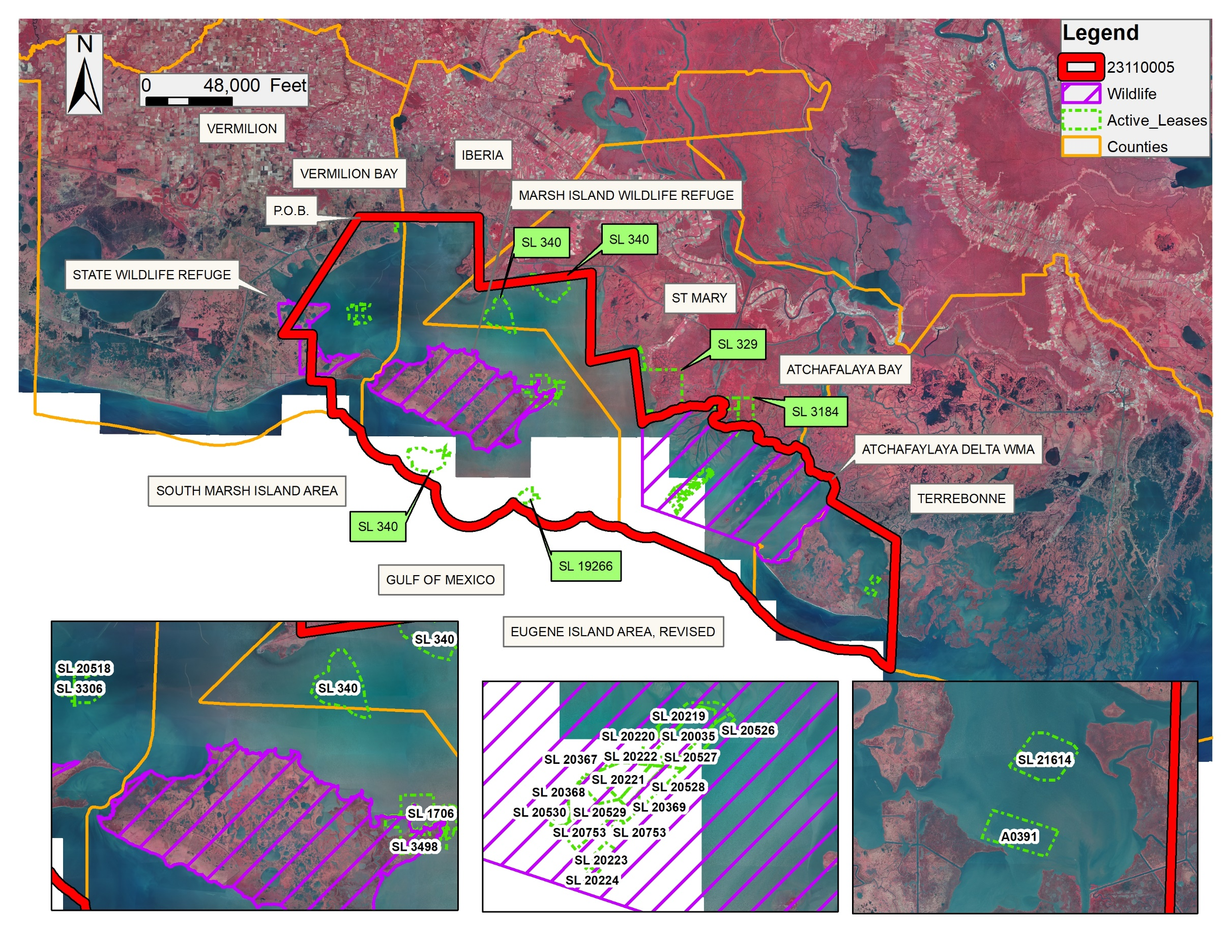
Office of Mineral Resources, Acres: 640671.77 Tract Number: 45685

